The Best anki settings and algorithm explained by an Expert.
subtitle

Heading 1

Heading 2

Heading 3

Heading 4

Link: The Anking

cards than they actually need to do. Video on the ReMemorize add-on: https://youtu.be/7gwigZHDLgg resetEZ add-on (to reset the Ease of ALL your cards)- https://ankiweb.net/shared/info/94793... See card info during review add-on: https://ankiweb.net/shared/info/21792... This NEW "Straight Reward" add-on could potentially have with avoiding ease hell (video to come in the future): https://ankiweb.net/shared/info/95796... Online Anki Mastery Course: https://courses.ankipalace.com

Tips:How to search in Browse section?

Tips: Buried,new,suspended,siblings?
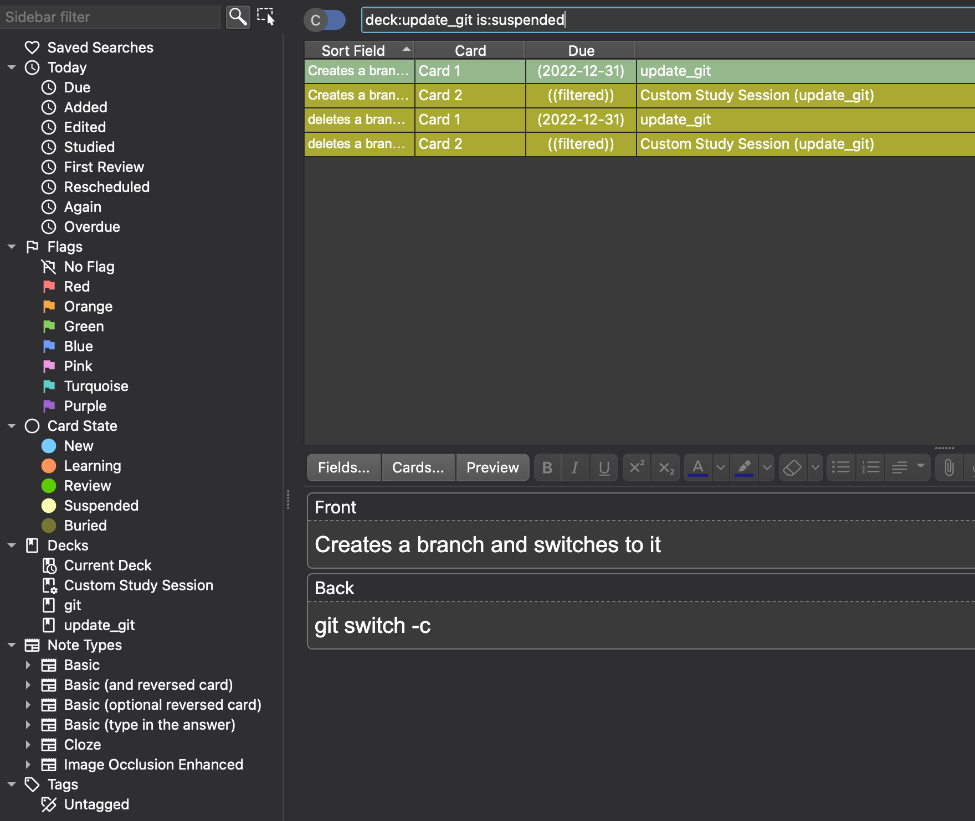
Deck:<deck_name>
Is:<status>

Status: New,Learning,Review, Suspended, Buried

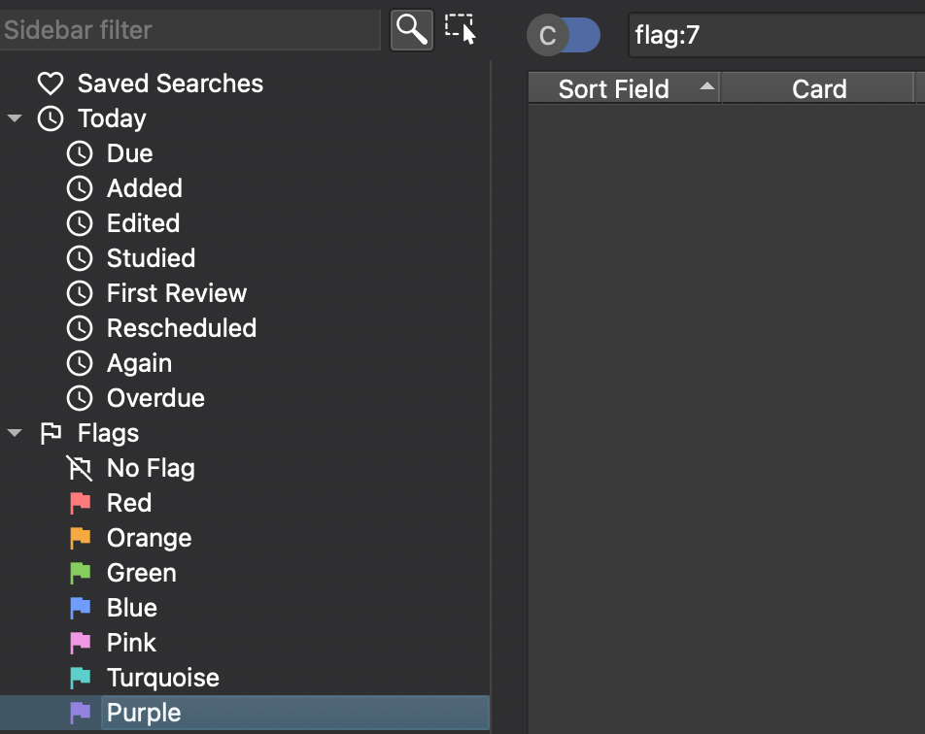 | 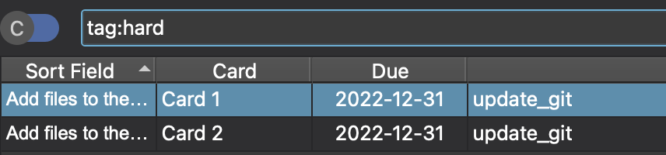  Buried are like the Jason from friday the 13. He’ll get up and start walking the next day.  Suspeneded: User input is required to unsuspend a card.
Buried cards: Buried cards don’t get shown. However at the start of every day every buried card get’s unburied.
Suspended card: Like burried cards, suspended cards don’t get shown. However they don’t get automatically unsuspended. To unsuspend a card you have to go to the card browser. Suspended cards have a yellow background in the card browser.
Sibling cards: All cards create by the same note are siblings. If you have a Note Type for learning German vocabulary the “Baum->tree” card and the “tree->Baum” card are siblings if they are created by the same note.
When you answer a card, all it’s siblings automatically get buried. This means that you won’t see the “Baum->tree”-card and the “tree->Baum” card on the same day.
Leeches: If a card get’s rated wrong at 8 separate days, it get’s tagged as a leech. The numbers of days can be changed in the settings.
This feature exists because it makes sense to bring special attention to leeches. Maybe you can rewrite the card to make it clearer and thus easier to answer? Maybe you violate the first rule of spaced repetition and try to learn something that you don’t understand? Maybe you need to add mnemonics to make it easier to remember the card?
Once you have determined how you want to deal with a certain leech you can unsuspend it. You can search in the card browser for “deck:current is:suspended” to see all leeches in your current deck.

What is sibling card and how bury works together
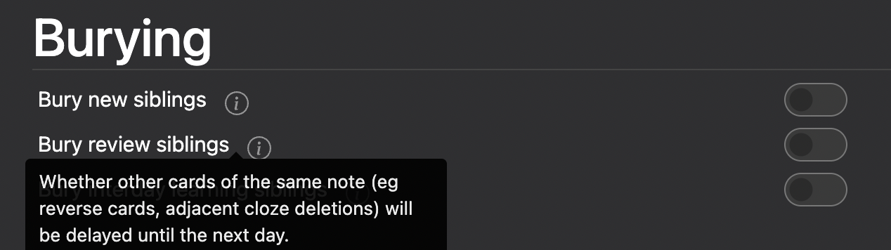

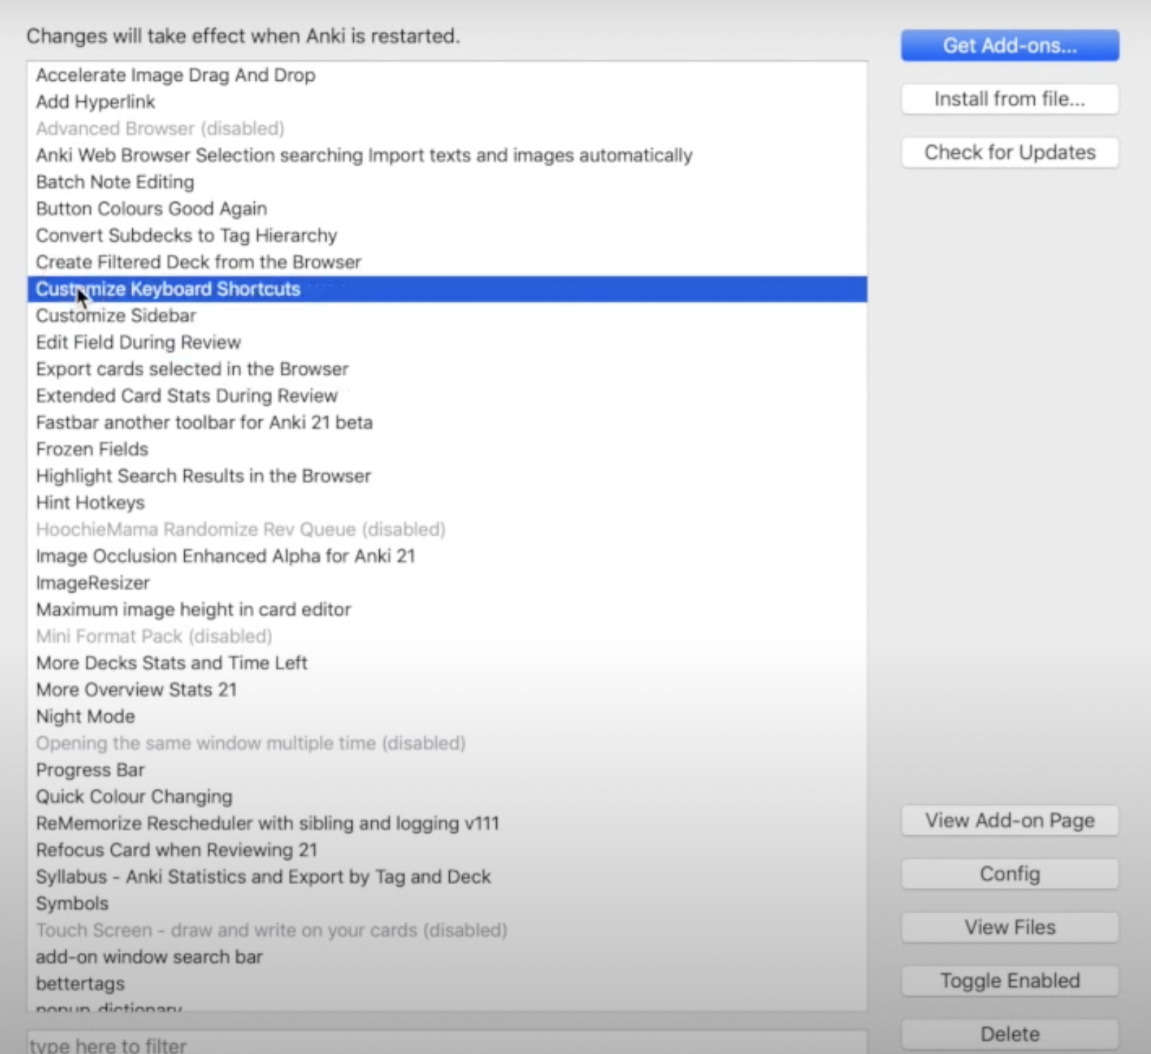
Tips:Addons:

Tips:Everything you do after the card is gradauted will affect the ease.
the lower the Ease Factor, the harder Anki thinks that card is. If you continually answer “Again,” Anki will keep knocking this card’s Ease Factor down until it reaches 130%, the lowest possible value.
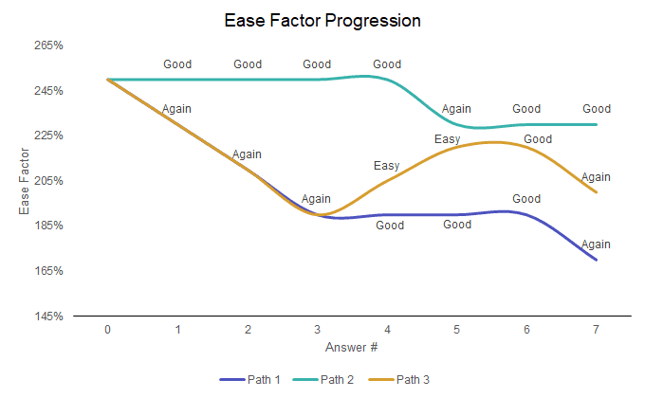

And once a card is beaten down to 130%, that means you’re going to see it more and more often forever!

Tip: What happens when a card gets graduated
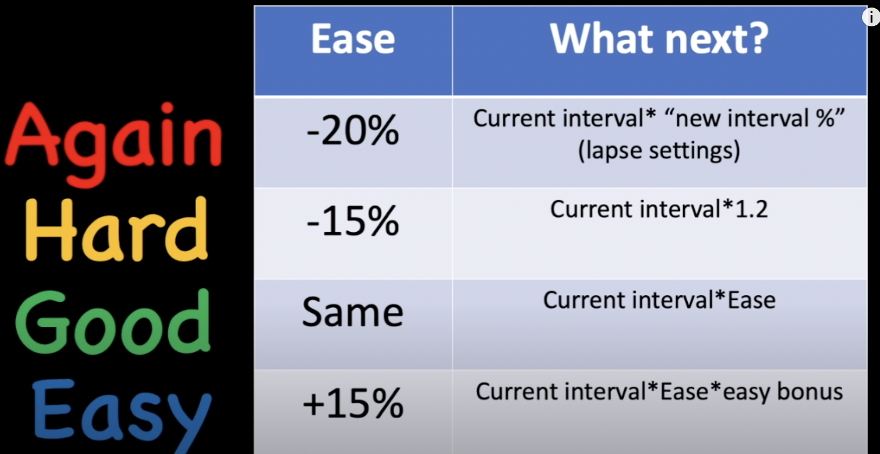

Tip: How to use cloze/basic/Image occulsion

Tip: How to put hints in cloze tag.

Ans:
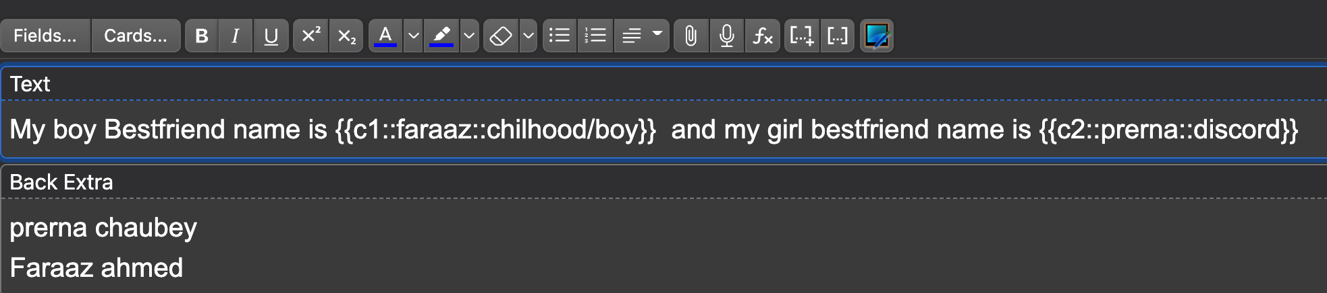

Tip: How to create sub-ankideck
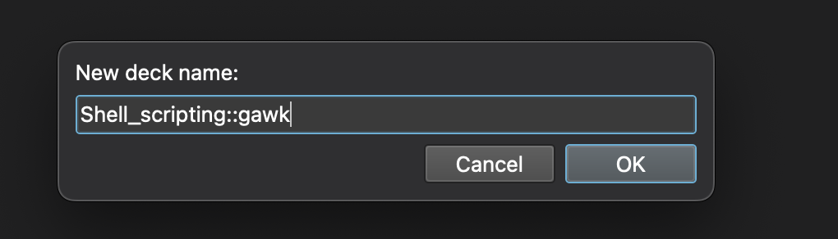



Tip: Difference between a note and a card
A card is something has only one cloze deletion and a note is a card that has multiple cloze deletion.
Suspend note: will suspend all of them.
Sadly it didn’t work.

Tip:why bury is useful
Lets say you hit show answers and u don’t know what to do, should I say its easy(4d), Good(3d), hard(1d).
So u could bury the card and decide tommorow.
Its like decision fatigue or we’ll see tommorow or lets procastinate today.

Tip:How to browse and tell what is going on buried, suspended,mark
Suspend | (442) with yellow highlighting
Buried | (442)
Mark | pruple

Tip: what are mature cards
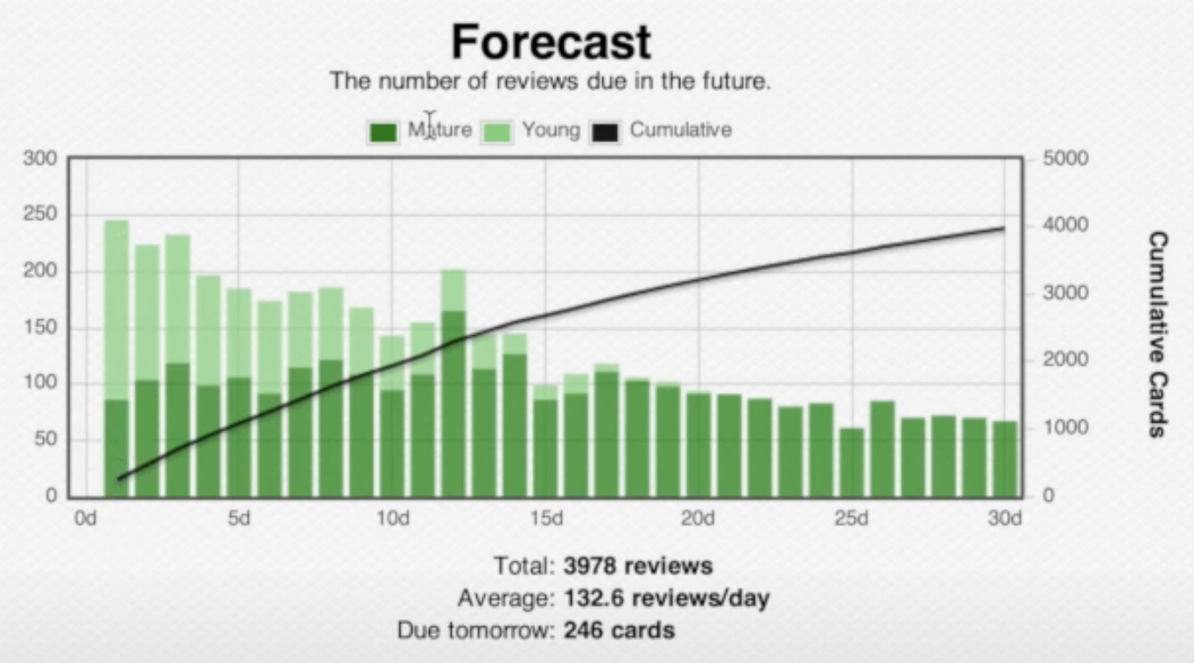Figure 1: mature card means they have an interval that is > 21 days

Tip: You don’t have to finish a deck.
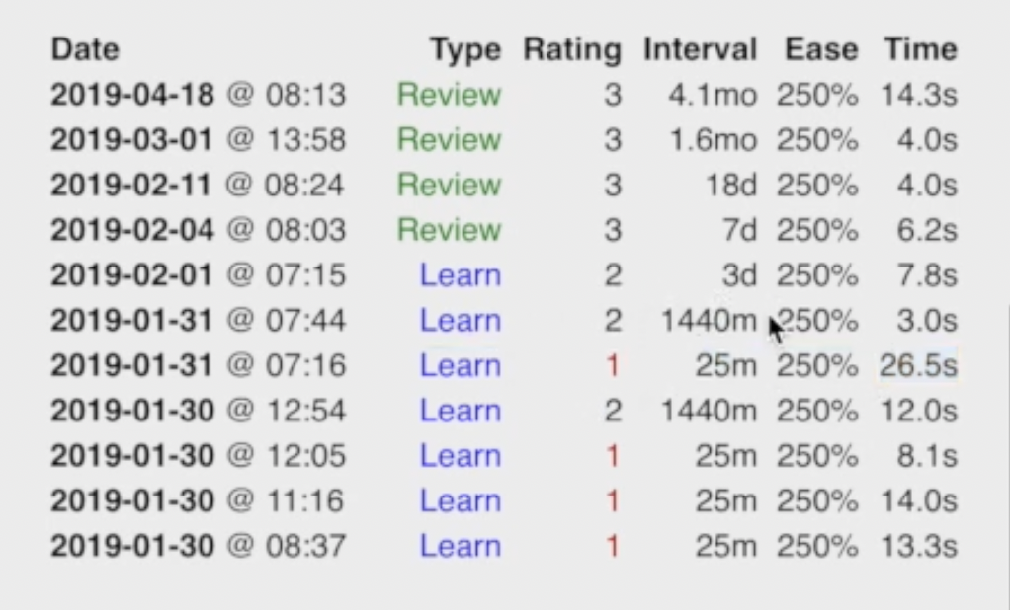

Tip: How to escape ease hell
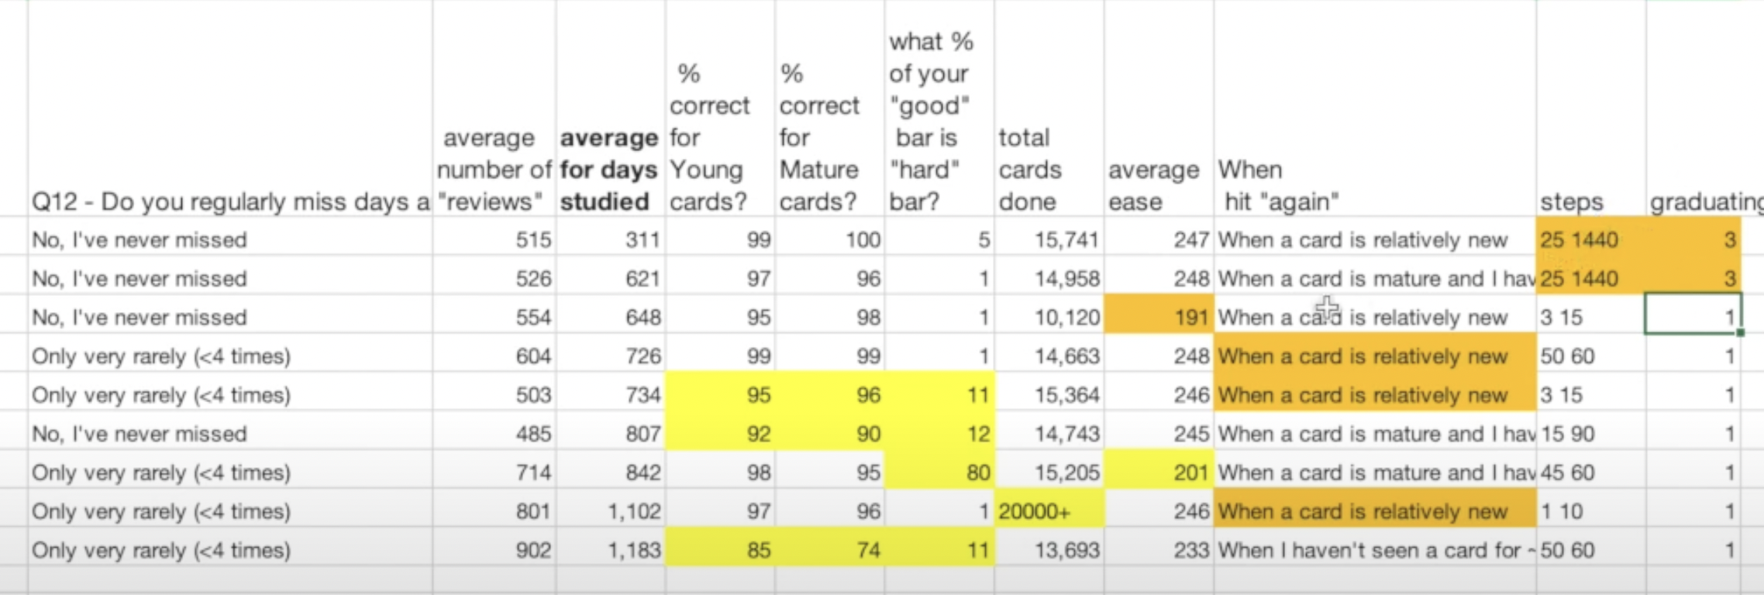
You could bury a card that needs more time and try to attack that card the next day.
Or you can rememorize → Reschedule, like u could send it a week in the future. Without changing the actual interval.
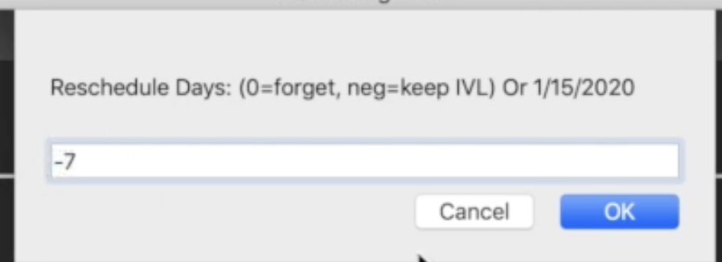

or
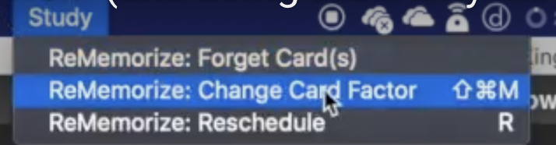

change the ease.
cards than they actually need to do. Video on the ReMemorize add-on: https://youtu.be/7gwigZHDLgg resetEZ add-on (to reset the Ease of ALL your cards)- https://ankiweb.net/shared/info/94793... See card info during review add-on: https://ankiweb.net/shared/info/21792... This NEW "Straight Reward" add-on could potentially have with avoiding ease hell (video to come in the future): https://ankiweb.net/shared/info/95796... Online Anki Mastery Course: https://courses.ankipalace.com

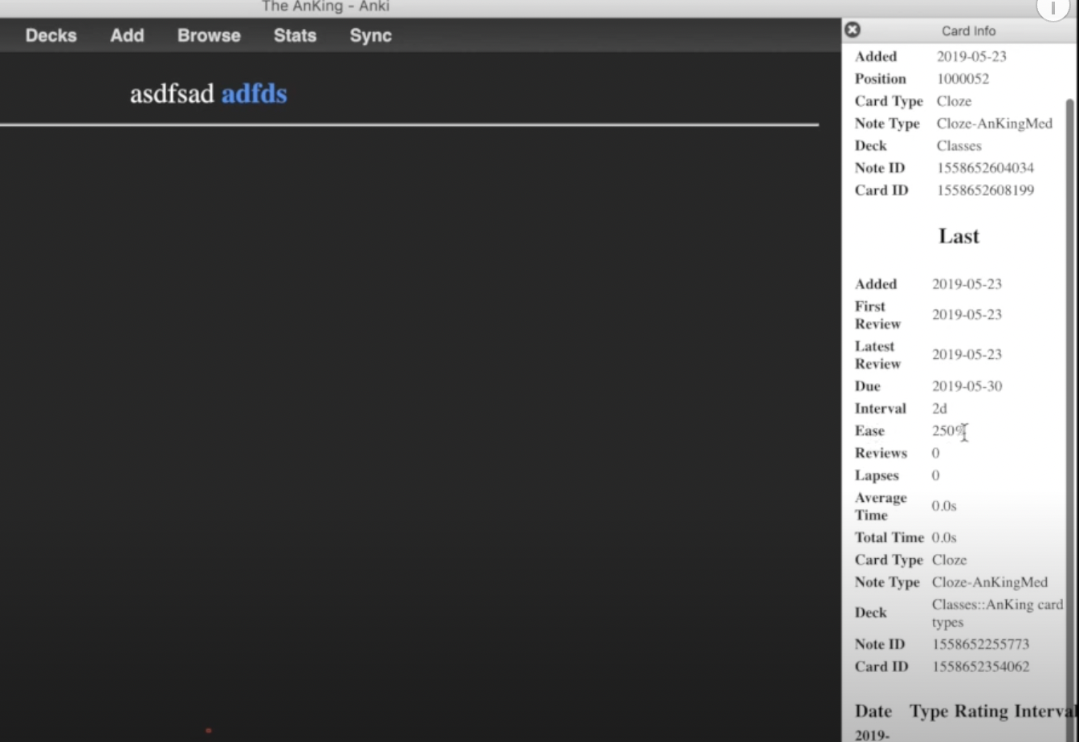Figure 2: this addon give u more details like ease
For more:click here:

Tip:How to export all decks
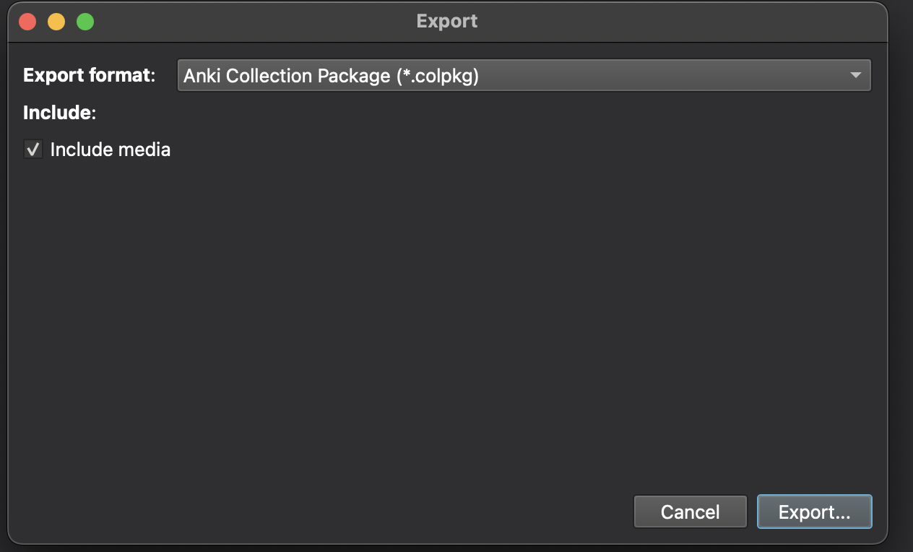

Another way:

where there is bookmarks and checkpoints.
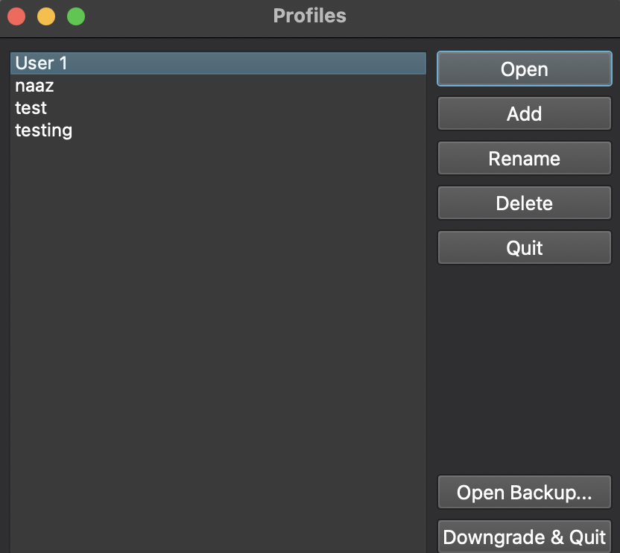Figure 3

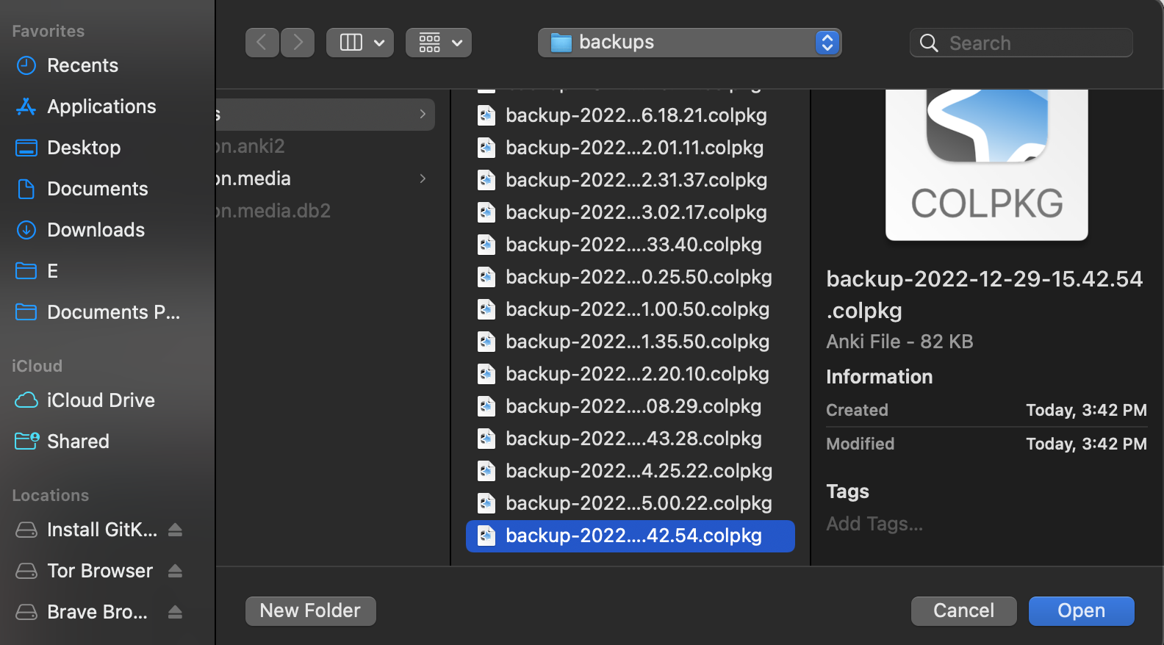

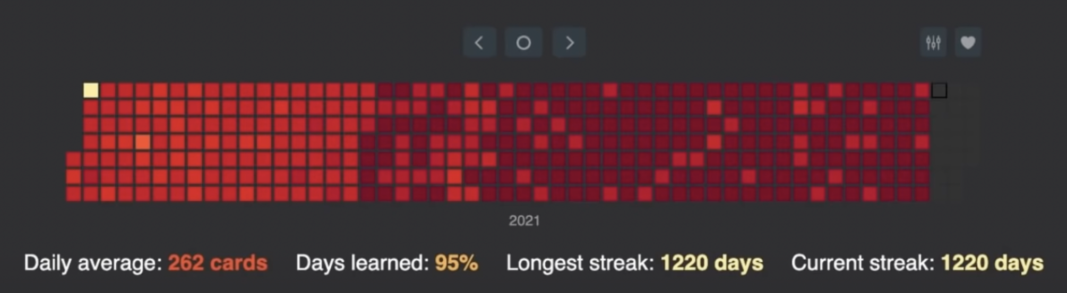

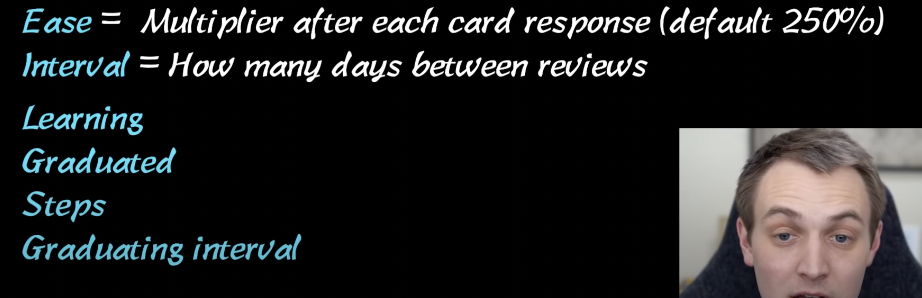

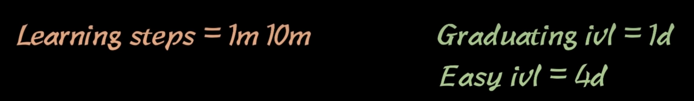
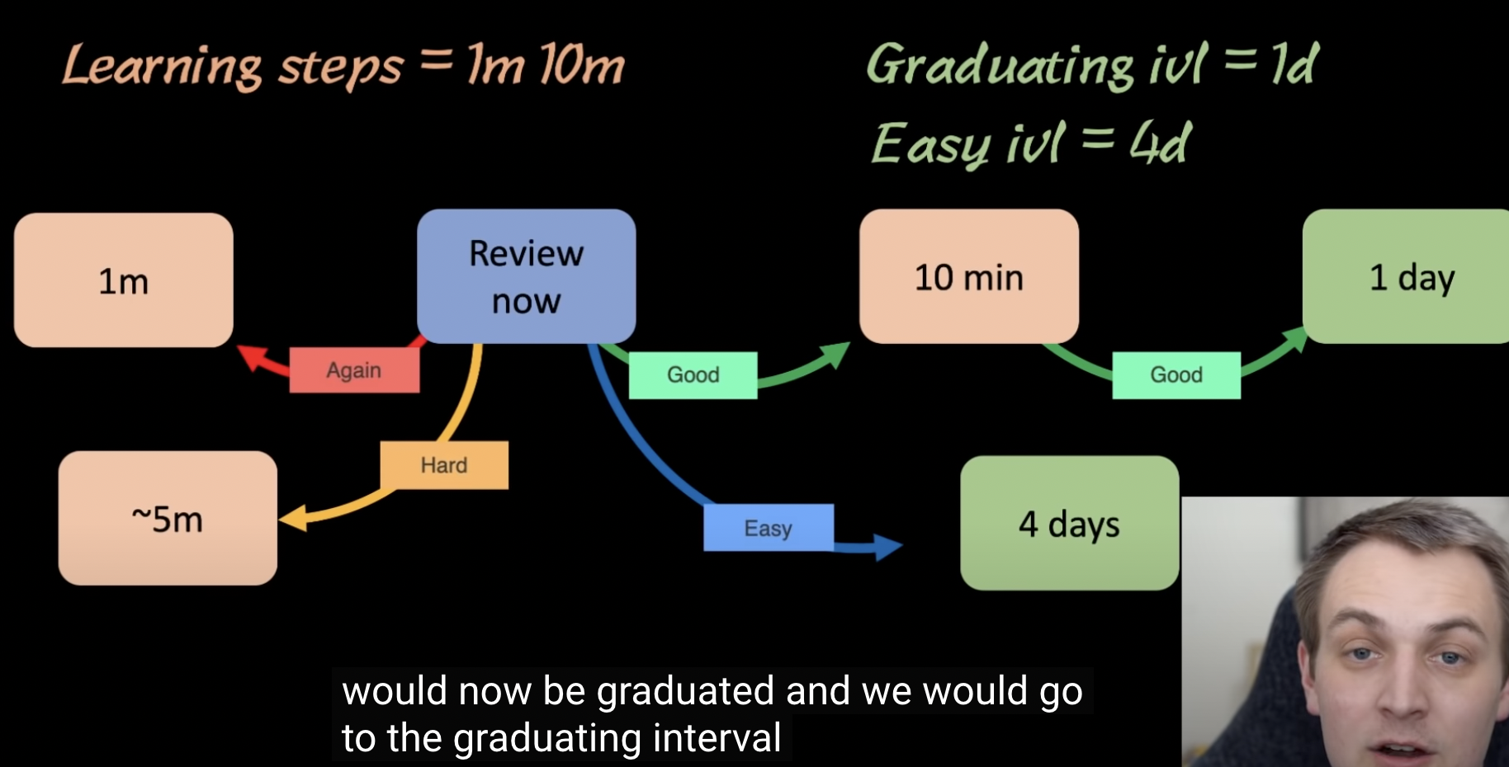
Good is the first learning step, if u do a good again, then you would be in Graduating ivl(interval) which is 1day.
Green means u r graduated.

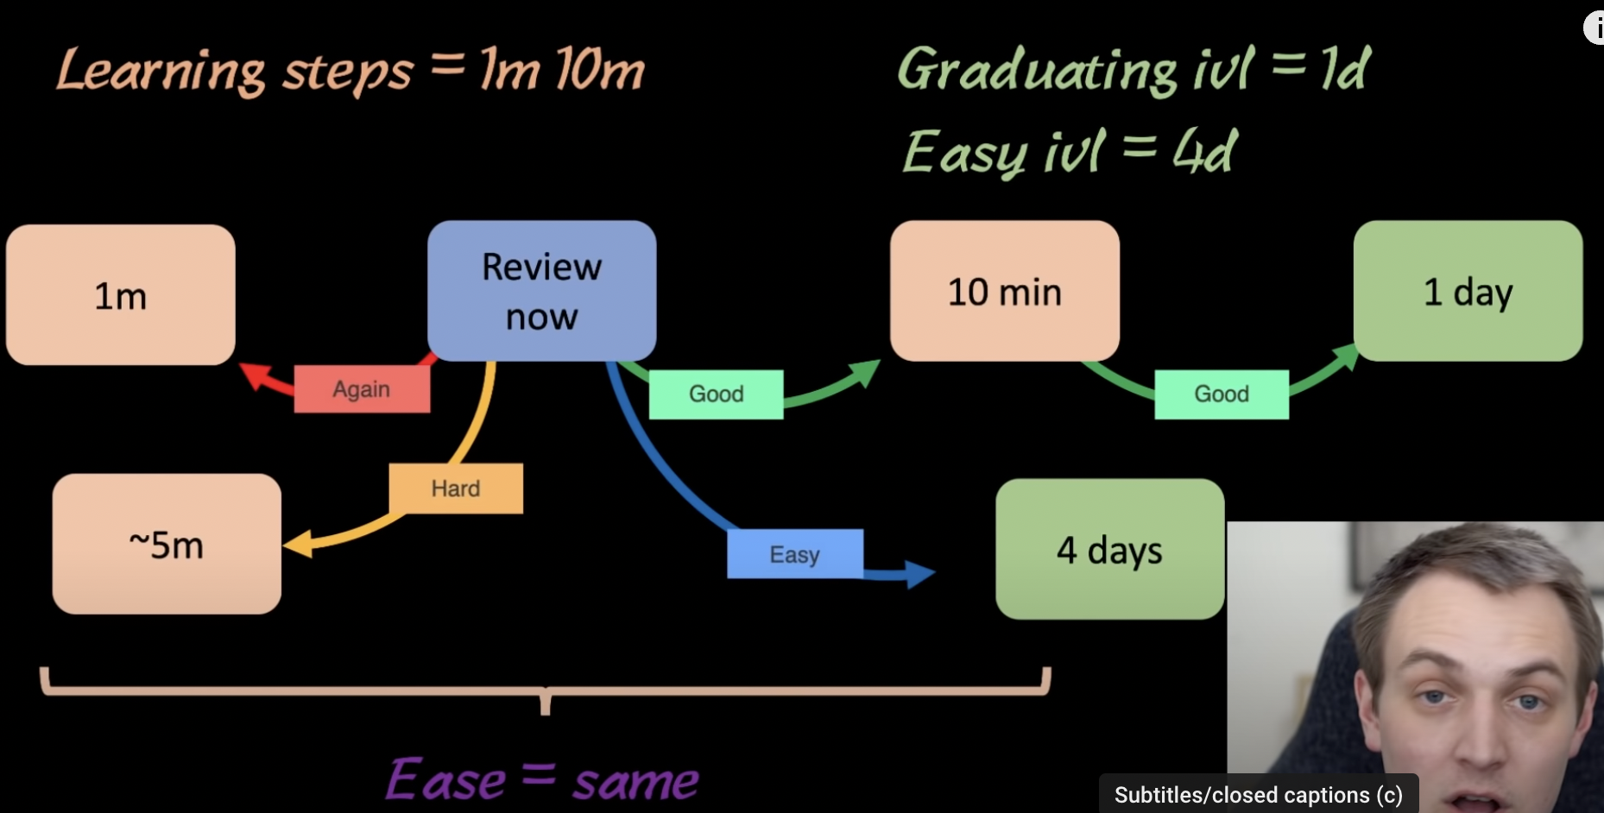

when the card is in the learning stage, the ease doesn’t change at all.
This is the instructors second video, and the difference between the older and this version, is that the card stays in the learning phase until tommorow.
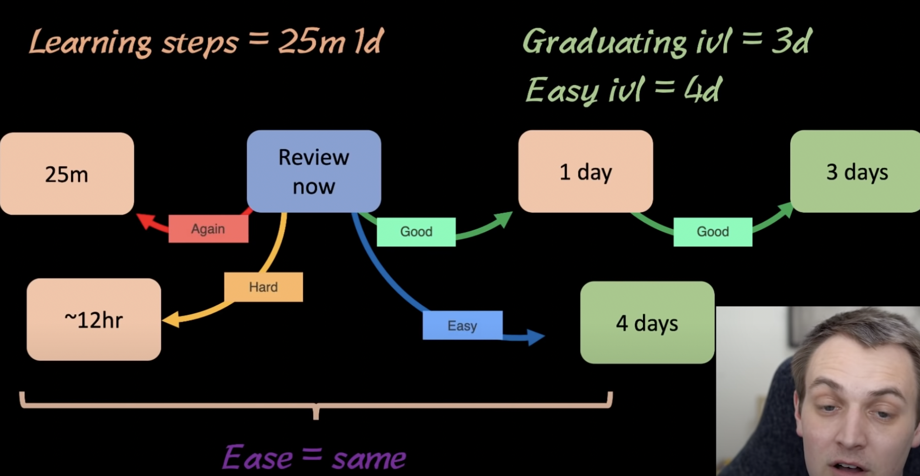
the way to solidfy something in ur brain, if u study something today and u wanna solidify, u should get it right tommorow.

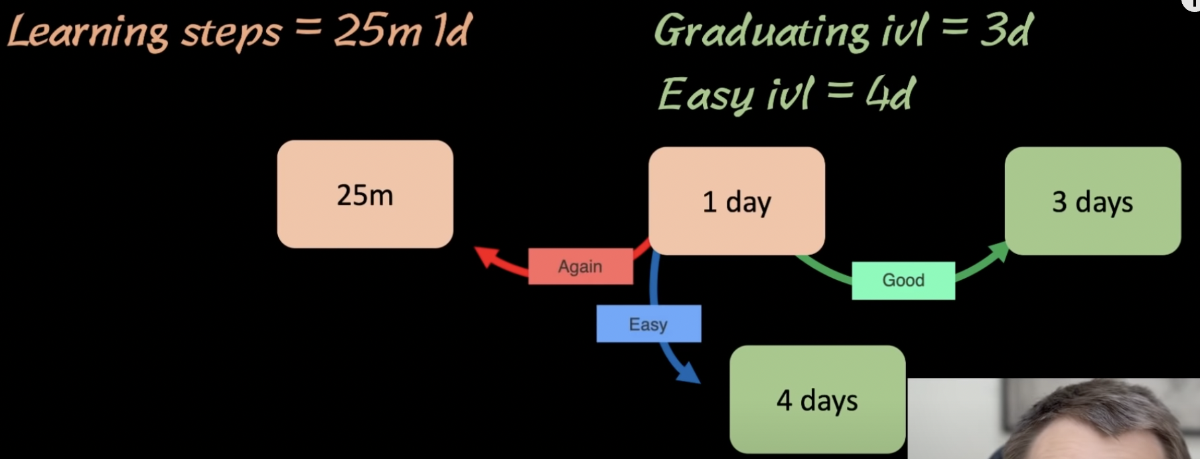
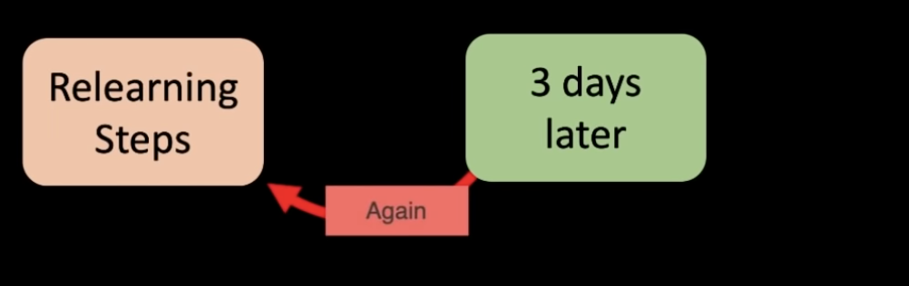Figure 4: good → good --> Again

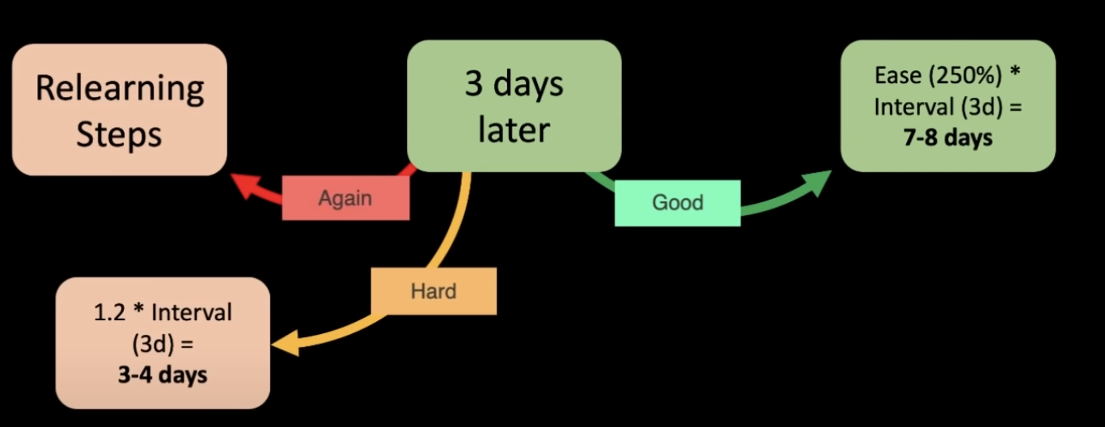

there is something called anki fuzz sometimes its 7-8 or 6-7 days. It changes a little. It applies to both Hard and Good.
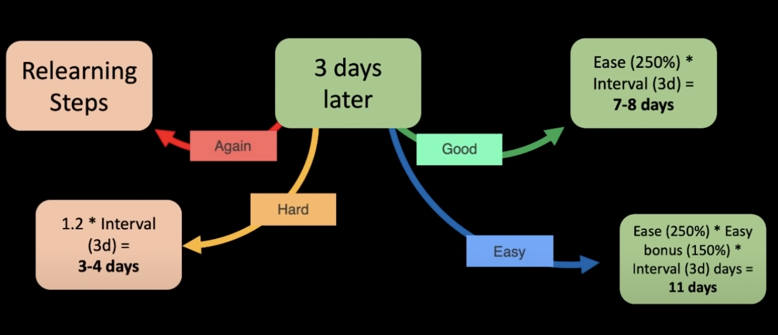

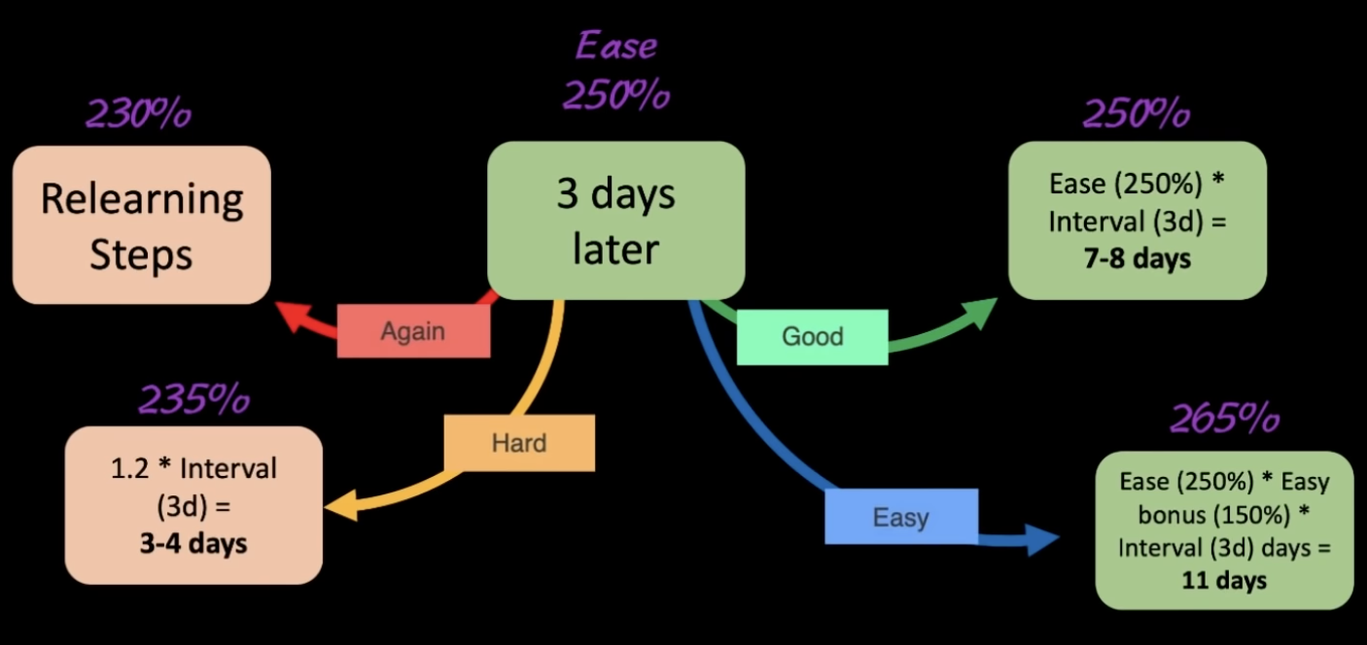Figure 5: Ease is gonna be constantly fluctuating

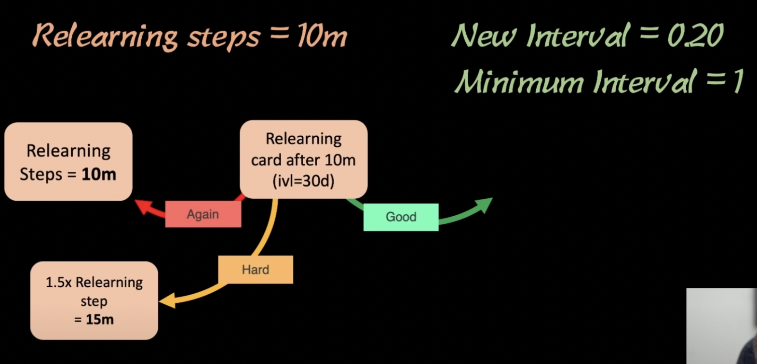

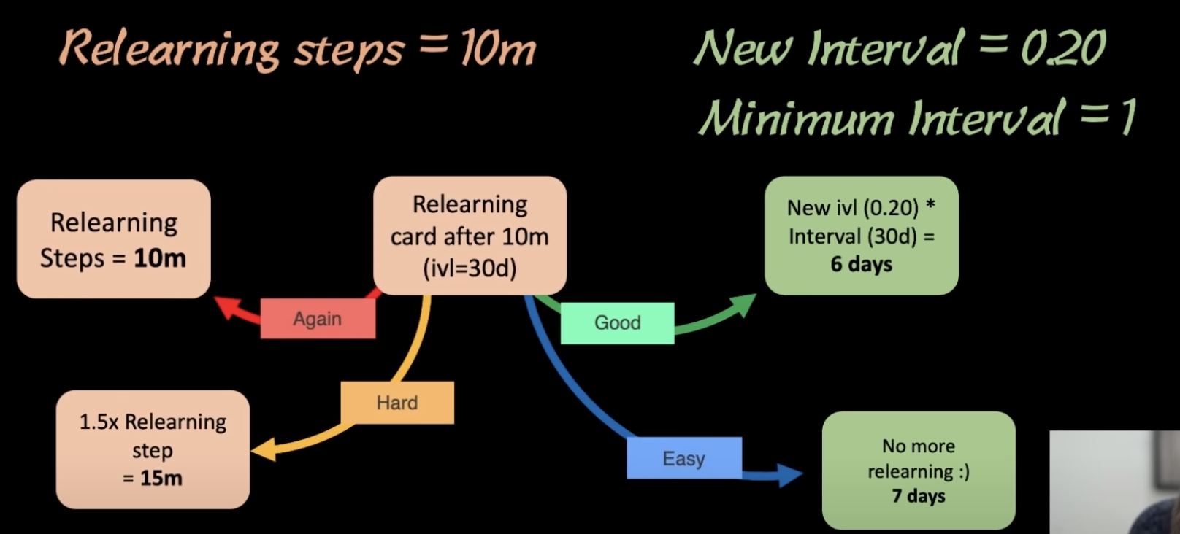Figure 6: Lets say our minimum interval is 15 days, just cause 6 days are less than 15. it will goto 15 days.
He generally left the minimum interval to be 1day.

Whenever u are in the learning or relearning phase the ease doesn’t alter.
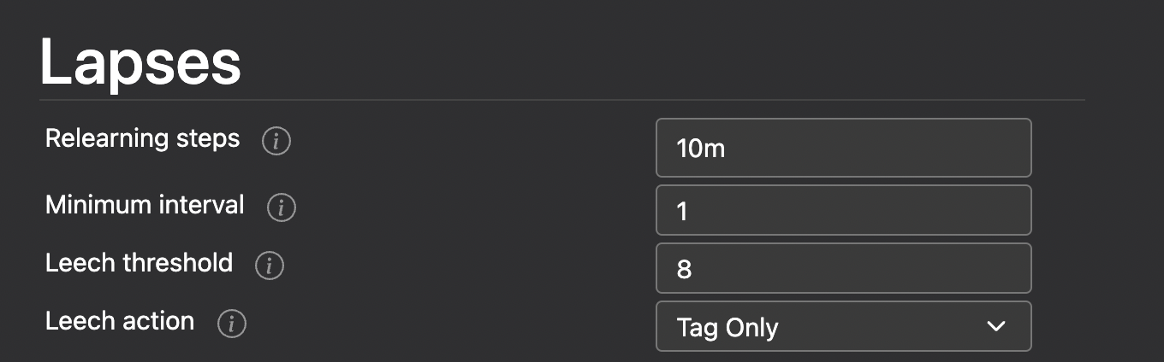

Anki settings:
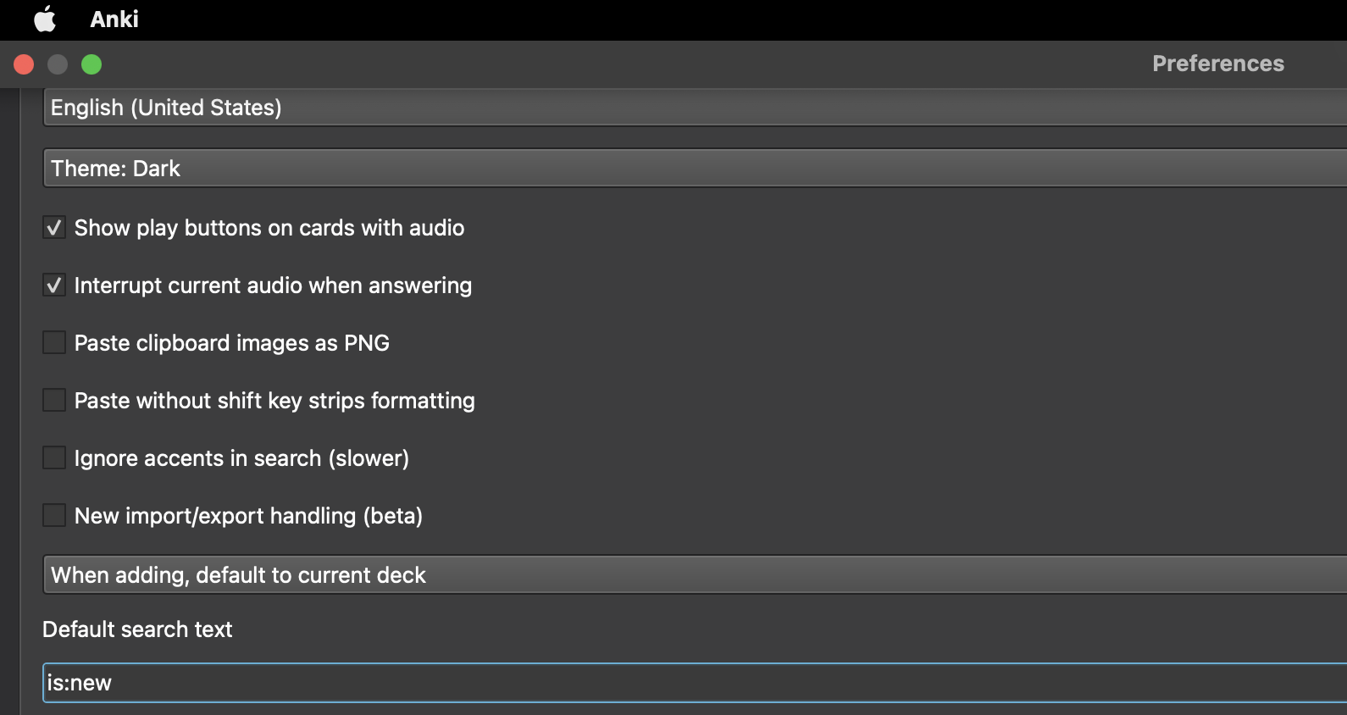Figure 7: Anki preferences

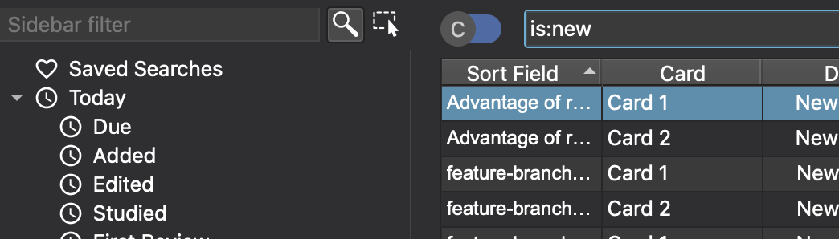
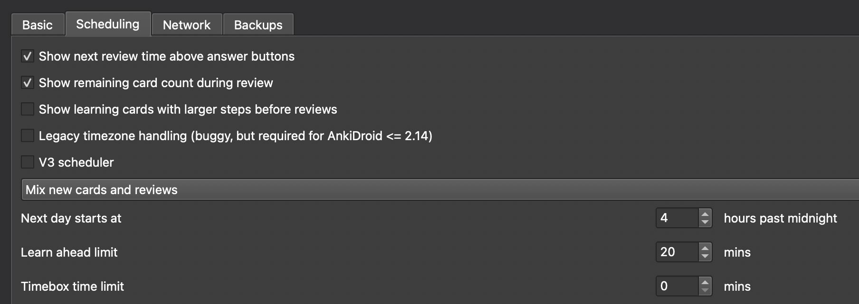
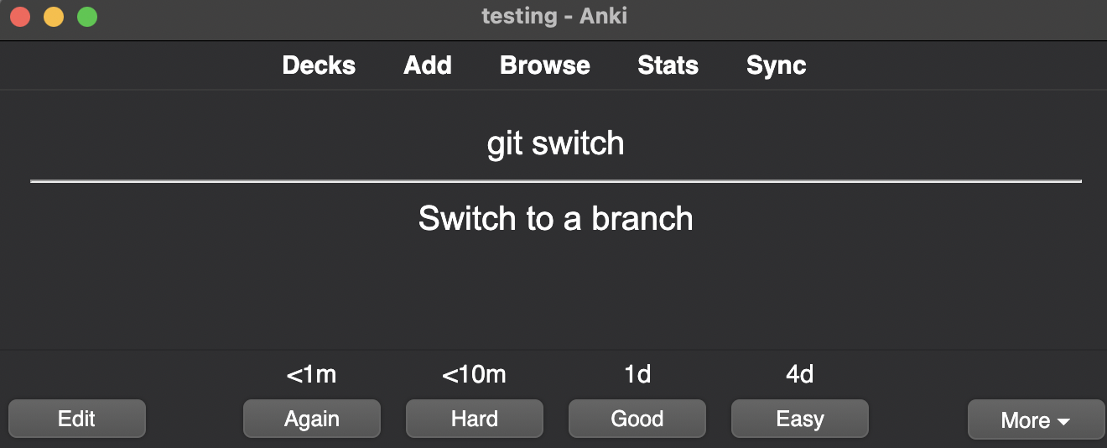
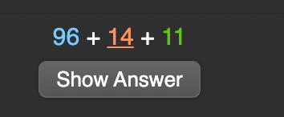

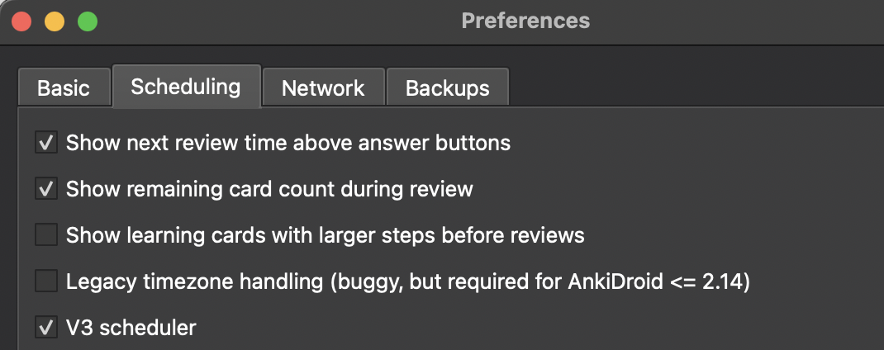Figure 8 preferences → V3 Scheduler

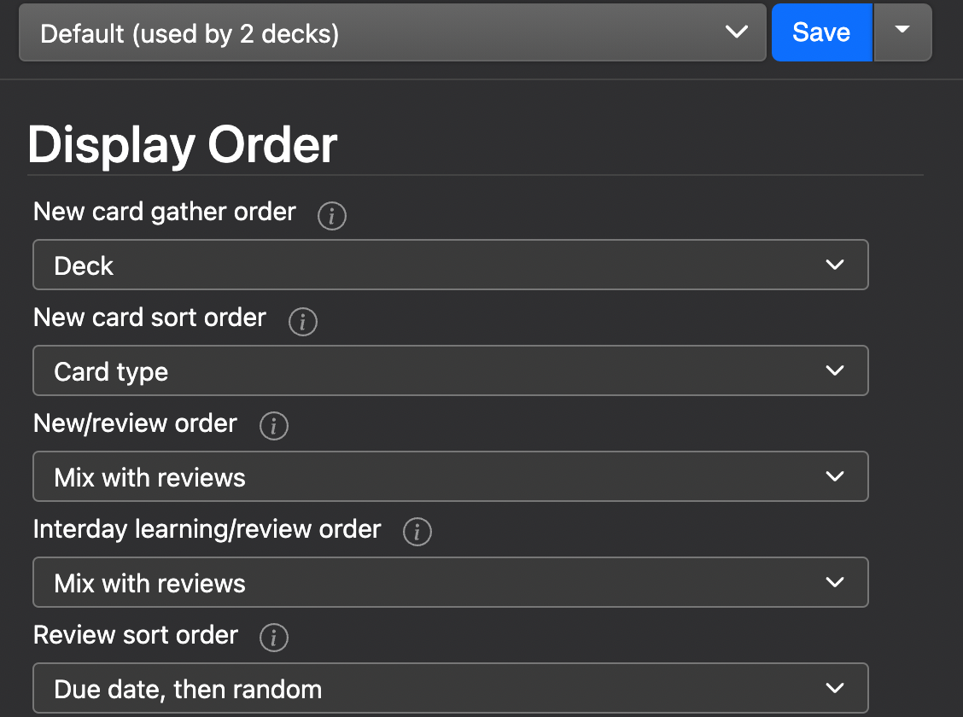

V3 scheduler open new settings that can come handy.

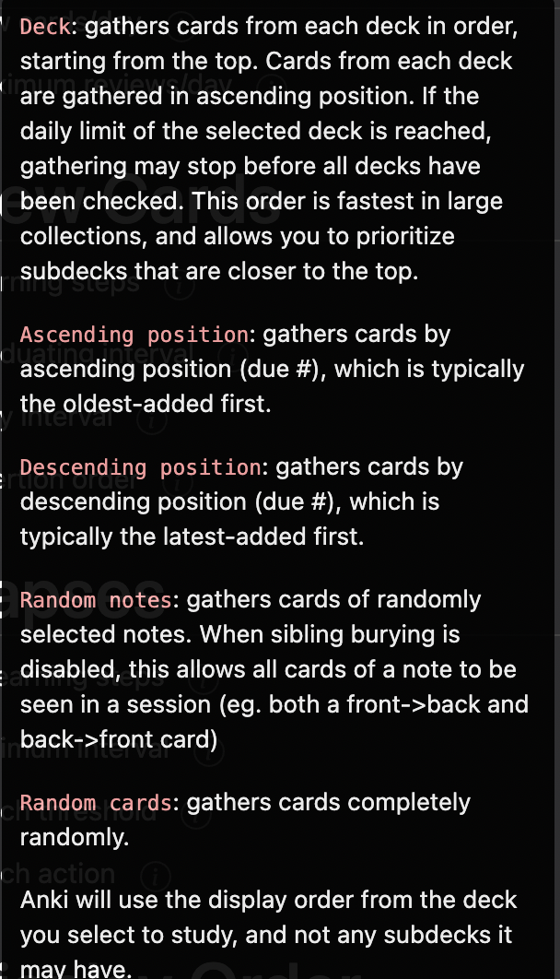 | 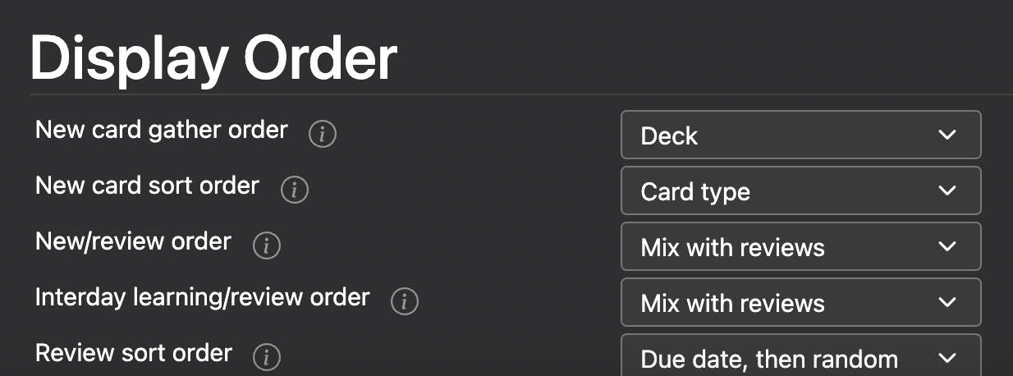

You can reposition a card: a new#1 to new#30 and that might affect card order.

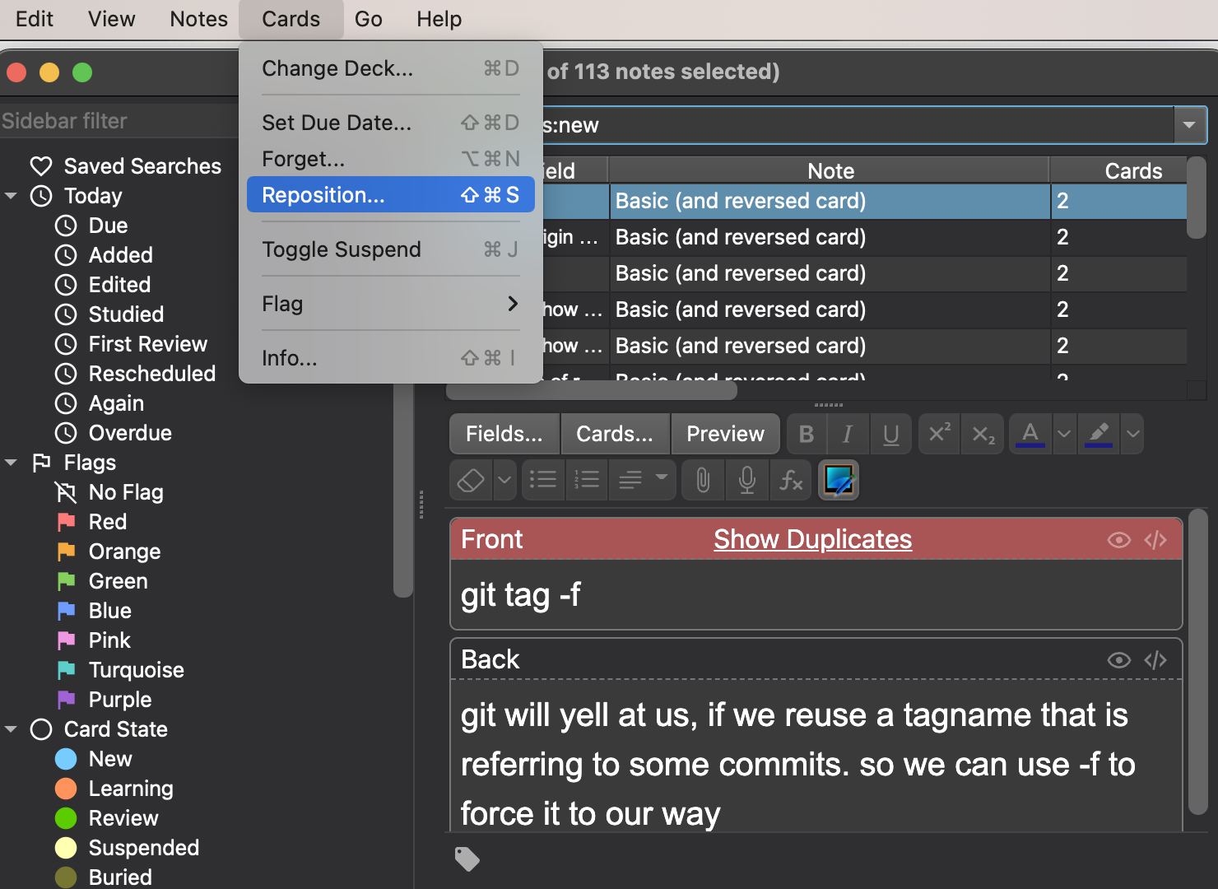

Y ou can select multiple cards and reposition them.

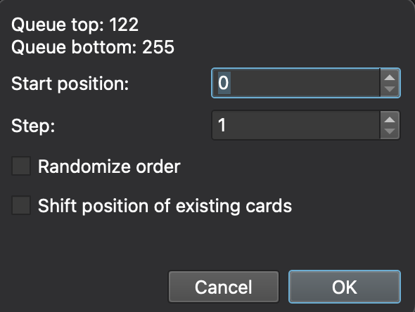
You can also randomize it.
Its pretty cool.

When the instructor is doing new cards, he preferred doing it in order I.e ascending.

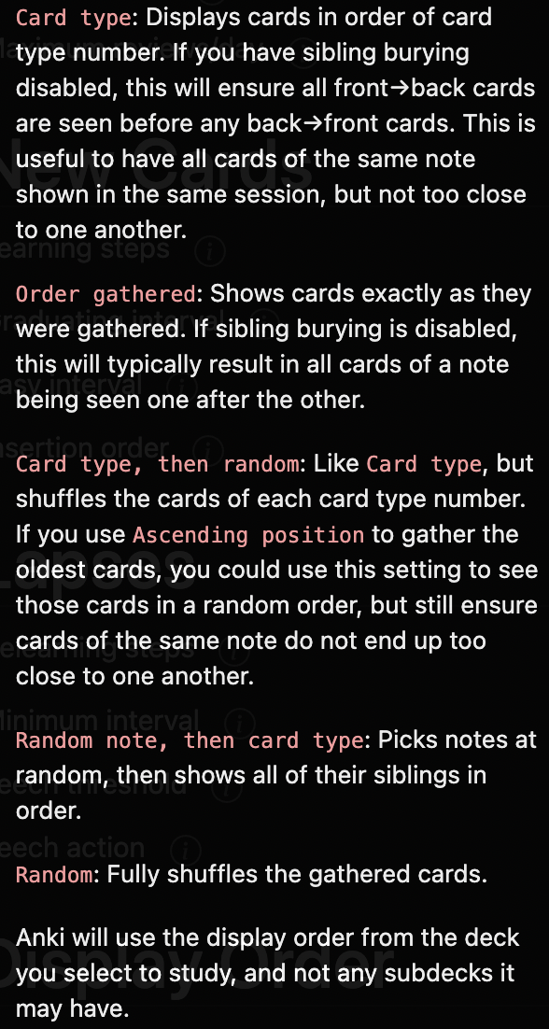

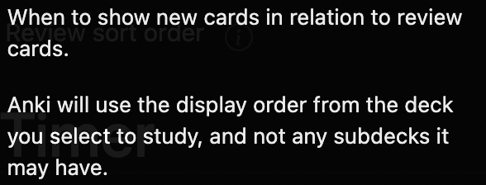 | 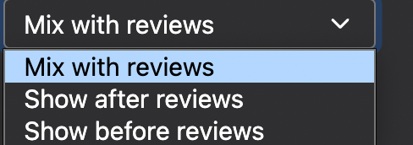  instructor prefer to do reviews first. That makes sense. Cuz you may get tired a lot after doing new cards. Atleast do the review cards.

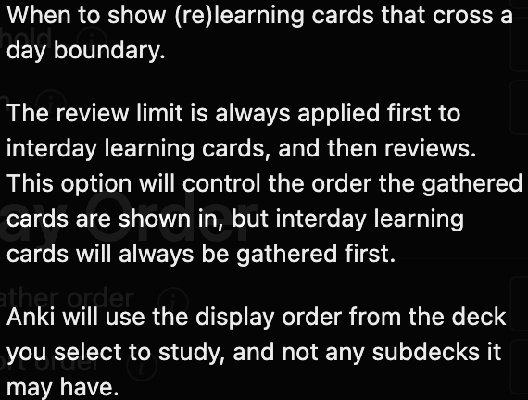 | 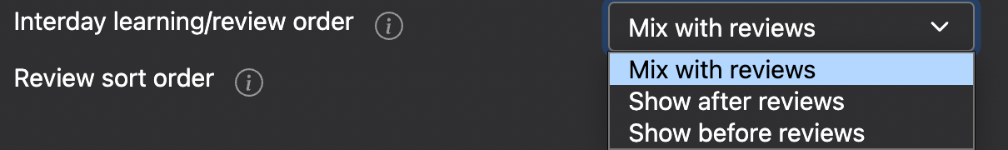  Example: (new:0 Learn:1 due:2)  Here interday card is only one  and review card is 2.  you from new card to interday card.

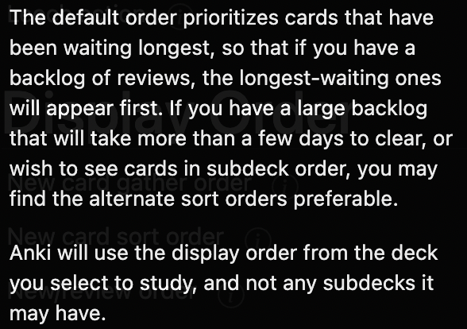 | 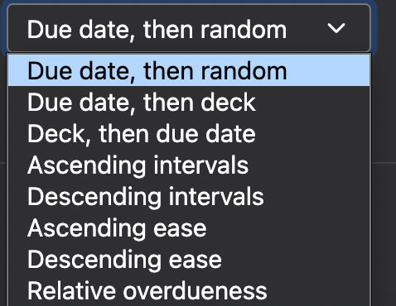

bACKUPS:

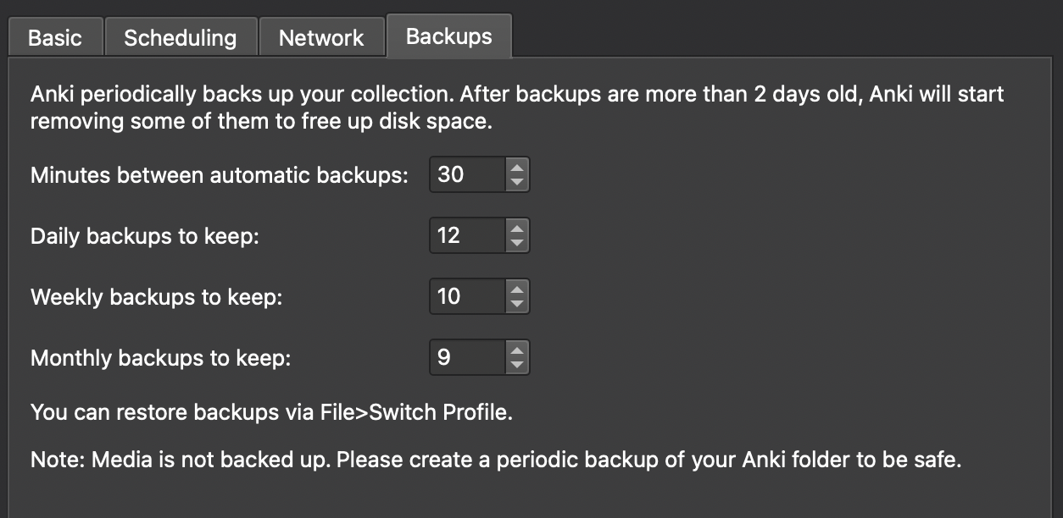

How to undo cards meaning give the ans again how good uknow the question again. Without using again.
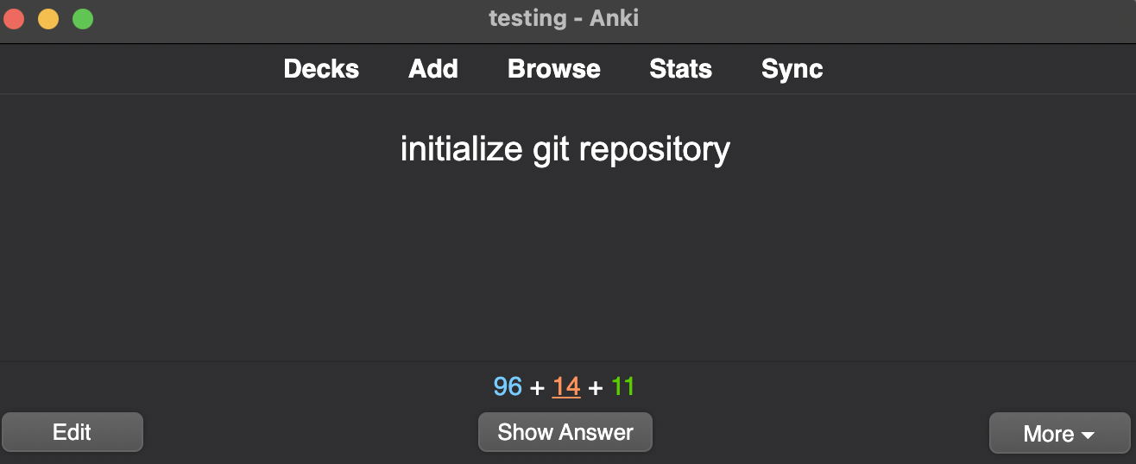

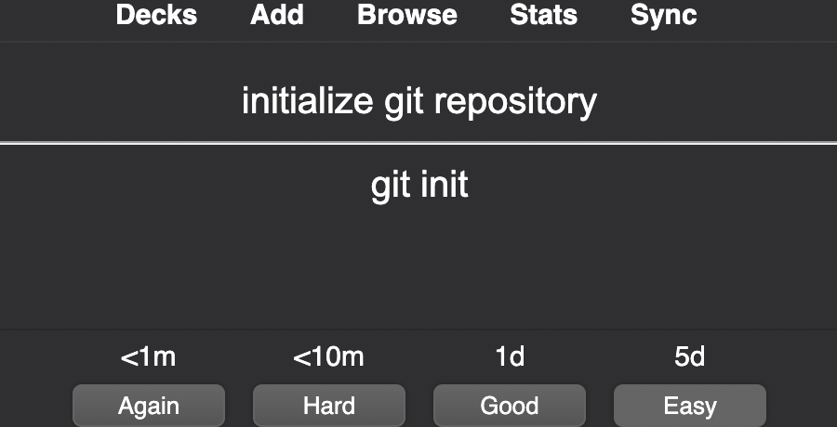

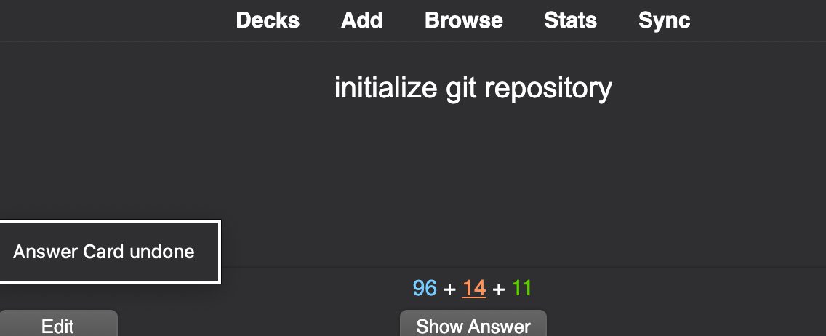Figure 9: ctrl+z. and u can go back as much as u like.

Anki simulator

